EXP.NO: 6 | Write a Servlet to demonstrate session tracking using HttpSession.
DATE:26/03/2025

AIM:
To demonstrate session tracking using HttpSession in a Servletbased web application. The exercise involves implementing a simple login system where a user can log in with their username and password, and their session will be tracked throughout their interaction with the web application.
ALGORITHM:
- Input:
  - The user will enter their username and password in a login form.
  - The servlet will validate the credentials and create an HTTP session for the user if authentication is successful.

- Steps for Implementing Session Tracking with HttpSession:
  - Create the Login Form (HTML):
      - Create an HTML form with two input fields for username and password.
      - Provide a submit button to send the data to the servlet for authentication.
  - Create the Login Servlet:
        - Write a Java servlet class to handle login requests.
        - The servlet will:
        - Retrieve the username and password from the form.
        - Authenticate the user by comparing the credentials to a stored value (e.g., hardcoded or from a database).
        - Create a new HTTP session for the user if the credentials are valid.
        - Set session attributes such as the user's username to track the session.
- Validate User Credentials:
    - In the servlet, check if the username and password match the expected values.
    - If valid, create a session and store the username in the session.
    - If invalid, redirect the user back to the login page with an error message.
- Create and Track User Session:
    - Upon successful login, use the HttpSession object to store the session data.
    - Use the session.setAttribute("username", username) method to save the username.
    - Optionally, set session timeout using session.setMaxInactiveInterval(time_in_seconds) to manage session expiration.
- Redirect to a Protected Page:
    - After a successful login, the user will be redirected to a protected page (e.g., a dashboard or home page).
    - The protected page should check if the user is authenticated by checking the session attribute.
- Logout and Session Invalidation:
    - Provide a logout feature that invalidates the session using session.invalidate() when the user logs out.
    - After logout, redirect the user back to the login page.
- Session Expiration:
• If the session expires or the user manually logs out, the session will be invalidated, and the user will be redirected to the login page.

Program:
Index.html
<!DOCTYPE html>
<html>
<head>
<title>Login Page</title>
<meta charset="UTF-8">
<style>
body {
font-family: Arial;
text-align: center;
margin-top: 100px;
}
form {
display: inline-block;
padding: 20px;
border: 1px solid #ccc;
}
input, button {
margin: 10px;
padding: 8px;
}
</style>
</head>
<body>

<h2>Login</h2>

<form action="app" method="post">
<input type="text" name="u" placeholder="Username" required><br>
<input type="password" name="p" placeholder="Password" required><br>
<button type="submit">Login</button>
</form>

</body>
</html>

AppServlet.java:
import java.io.*;
import javax.servlet.*;
import javax.servlet.http.*;
import javax.servlet.annotation.*;

@WebServlet("/app")
public class AppServlet extends HttpServlet {

protected void doPost(HttpServletRequest req, HttpServletResponse res)
throws IOException {

String u = req.getParameter("u");
String p = req.getParameter("p");

if("admin".equals(u) && "123".equals(p)) {
req.getSession().setAttribute("user", u);
res.sendRedirect("app");
} else {
res.getWriter().print("Invalid Login");
}
}

protected void doGet(HttpServletRequest req, HttpServletResponse res)
throws IOException {

res.setContentType("text/html");
PrintWriter out = res.getWriter();

if(req.getParameter("logout") != null) {
HttpSession s = req.getSession(false);
if(s != null) s.invalidate();
res.sendRedirect("index.html");
return;
}

HttpSession s = req.getSession(false);

if(s != null && s.getAttribute("user") != null) {
out.println("<h2>Welcome " + s.getAttribute("user") + "</h2>");
out.println("<a href='app?logout=true'>Logout</a>");
} else {
res.sendRedirect("index.html");
}
}
}

Output:
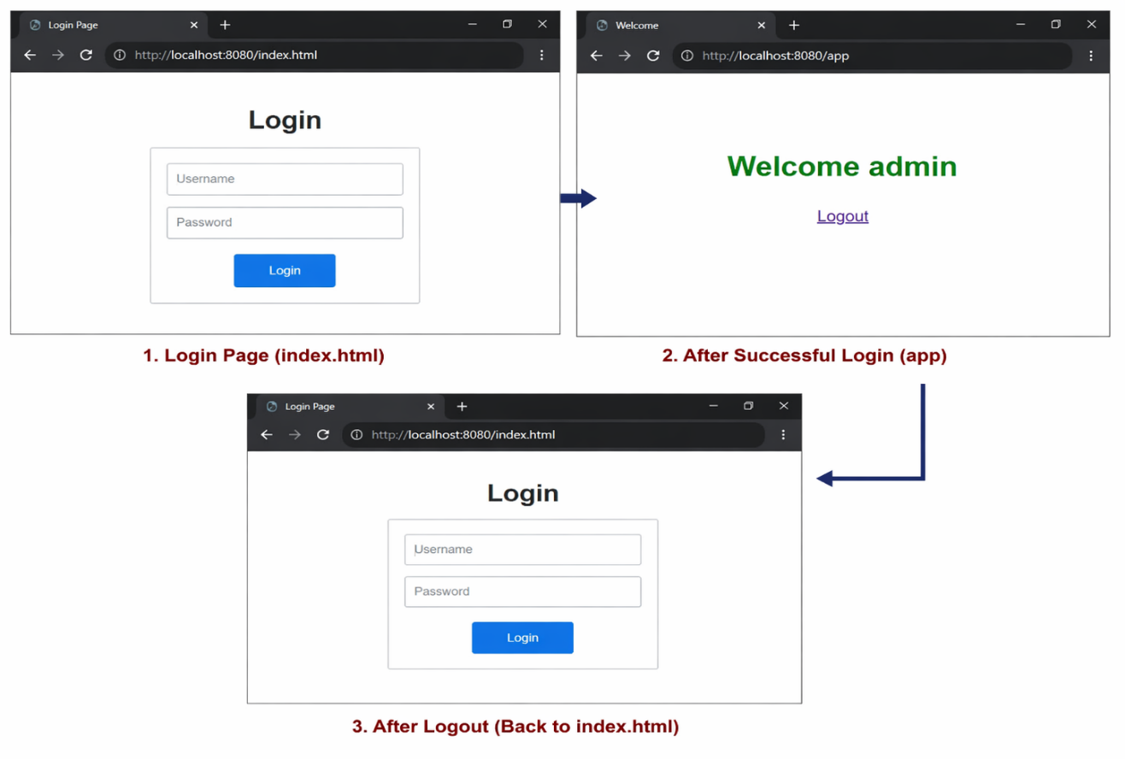

RESULT:
A simple login system is created where the user's session is tracked by a servlet to demonstrate session tracking using HttpSession.

